**Mr. Visca’s: Calculus (Chpt 4.6)**

**Chpt 4 – Day 11: Related Rates**

**4.6 Related Rates**

We can differentiate an equation that relates 2 variables with respect to time to find how the rates are related.

Example 1

The radius of a sphere is decreasing at a rate of 0.5 cm/sec. What is the rate of change of its volume when r = 20?

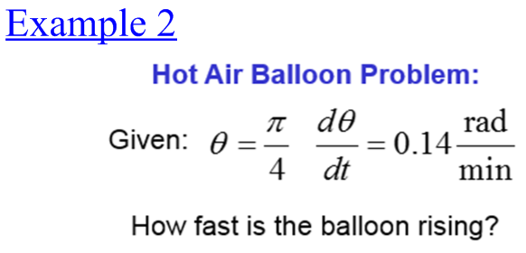

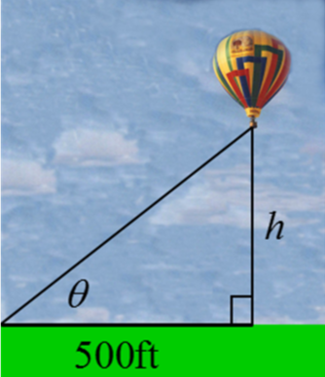

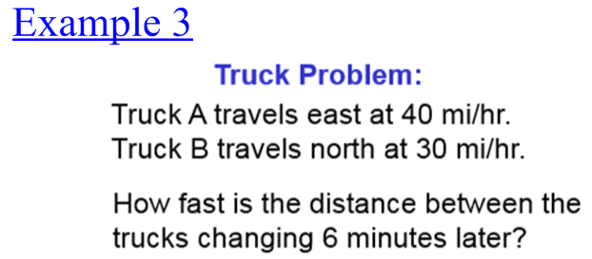



Example 4: Falling Ladder

A 10-foot ladder leans against a vertical wall. The base of the ladder is pulled away from the wall at a constant rate of 2 ft/sec. At what rate is the top of the ladder falling when the base of the ladder is 8 feet from the wall?

Example 5

Water runs into a conical tank at the rate of 9 ft3/min. The tank stands point down and has a height of 10 ft and a base radius of 5 ft. How fast is the water level rising when the water is 6 ft deep?

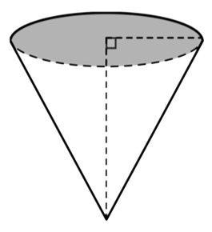

**HOMEWORK:**

Section 4.6 (7ab, 8, 9abc, 11, 13, 15, 19)